Name_____________________________
Label and define the parts of an atom.
___/4
Parts of an Atom Exit Slip
Match the particle to the correct location and charge.
____ 1. Proton | - Negative | - Nucleus
____2. Electron | - Positive | - Electron Cloud
____3. Neutron | - Neutral

4. Label the diagram of the atom below.
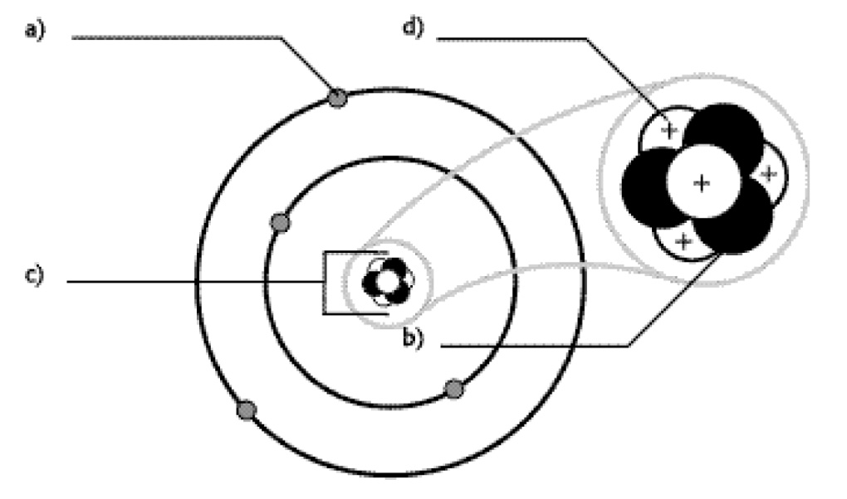

Name_____________________________
Label and define the parts of an atom.
___/4
Parts of an Atom Exit Slip
Match the particle to the correct location and charge.
____ 1. Proton | - Negative | - Nucleus
____2. Electron | - Positive | - Electron Cloud
____3. Neutron | - Neutral

4. Label the diagram of the atom below.

